**Master Functional Document**

|  |  |
| --- | --- |
| **Application** | NGERP - Centra |
| **Service Bundle** | Master Management |
| **Service Request** | Tax Rate |

**Description :**

Tax Rate Master is used the calculate the tax rate and it also defines the GL accounts each tax rate should be posted. The tax amount will be calculated from the invoice.

**Workflow Process :**

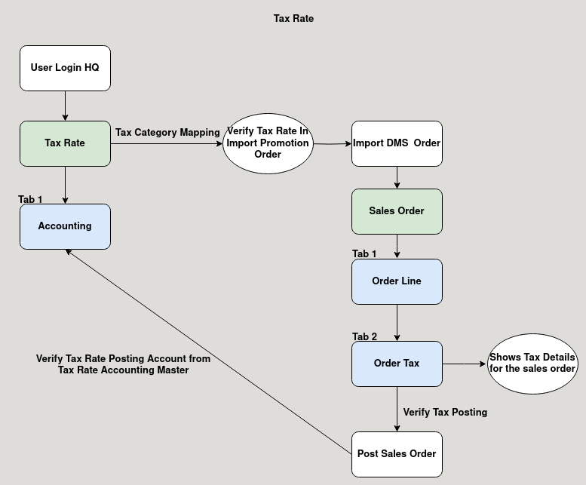

**Business Rules :**

* Tax Rate can be only added in HQ.
* The tax rate is set in the rate field.
* Accountig Tab is used to map the GL Account.
* For example when importing a Promotion order from DMS with the tax rate.
* It checks the tax rate from the tax master and calculate the tax amount for the promotion order.
* After posting the tax amount will be posted in the accounts defined in the Tax Rate Accounting Master.